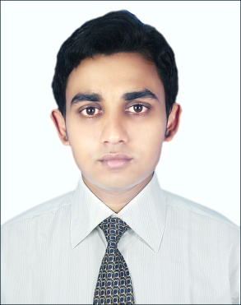

A k m motaherur Rahaman

House-08,Lane -03,Gulshan-Badda Link Road

Cell-+8801711738685

[Email-m.rahaman1@hotmail.com](mailto:Email-m.rahaman1@hotmail.com)

|  |  |  |  |
| --- | --- | --- | --- |
| Objective | Aspire to acquire a better position as a professional Finance specialist in MNC organization and gain global experience in the fields of Finance & Banking. Wish to utilize my Finance skills & abilities for the development of the organization. | | |
| SUMMARY | Dedicated and ethical Finance & Banking specialist, focused on implementation of appropriate control strategies on possesses. Has a MBA degree in Finance & Banking and significant experience with count and control methodologies. | |
| Special qualification | Ability to meet strict deadlines Detail-oriented Excellent numerical and logical analytical skills Ability to manage multiple tasks  A methodical approach to figures and reporting. Dependable employee  good team player. | |
| employment History | **Executive Officer ( Jan 1, 2017 - Continuing)**  **Toma Construction & Co Ltd**  Company Location : 77/1, Toma Tower, Kakrail, Dhaka,1000  Department: Accounts & Finance  **Responsibilities:**  **General Banking (all kind of banking work).**  **Bank Reconciliation. Reconciliation of general fund, project. Reconciliation of inventory, project, accounts. Fixed asset registration update. Site voucher posting in Tally Software. Daily cash / Bank voucher posting. Ensure that all MRIR/ Invoices of the goods and Requisitions are archived along with its hard copy. Perform extra duties when called upon especially in an emergency. Assisted with internal audits.** | |
| Education | MBA. Finance & Banking Under International Islamic University Chittagong. Passing year -2013  BSS Honors MSS Economics Under National University. Passing year -2008 and 2009. | |
| Professional Qualification | English for Professionals.  **Institute-**International Islamic University Chittagong  Computer Office & Troubleshooting  **Institute-** Department of Youth Development Ministry of Youth and Sports | |
| language | Bangla. English .Hindi. | |
| personal details | Father Name : A K M Mominur Rahaman  Mother : Nazma Rahman  Date of Birth : 31-12.1985  Marital Status : Single  Permanent Add : H#275,Kamal Hazari Road, Academy, Feni 3900 | |
| Reference | |  |  |  |  | | --- | --- | --- | --- | |  |  | Reference: 01 | Reference: 02 | | Name | : | Dr.Mokadesur rahman | MD Shamchuddin Chowdhuri FCA | | Organization | : | Chomuhani Govt S A College | Toma Construction & Co.Ltd | | Designation | : | Professor | Director,Audit. | | Address | : | Chomuhani Govt College,Noakhali. | 77/1.Toma Tower,Kakrail,Dhaka 1000. | |  |  |  |  | |  |  |  |  | | Mobile | : | +8801712973258 | +8801730001026 | |  |  |  |  | |  |  |  |  | |  |  |  | | | |
|  | |



……………………………. 25-12-2017

A K M Motaherur Rahaman Date: ………………